EXPERIMENT 16: - Change Hardware compatibility of a VM (Either by clone/create new one) which is already created and configured.

Step 1: - Open the existing virtual machine

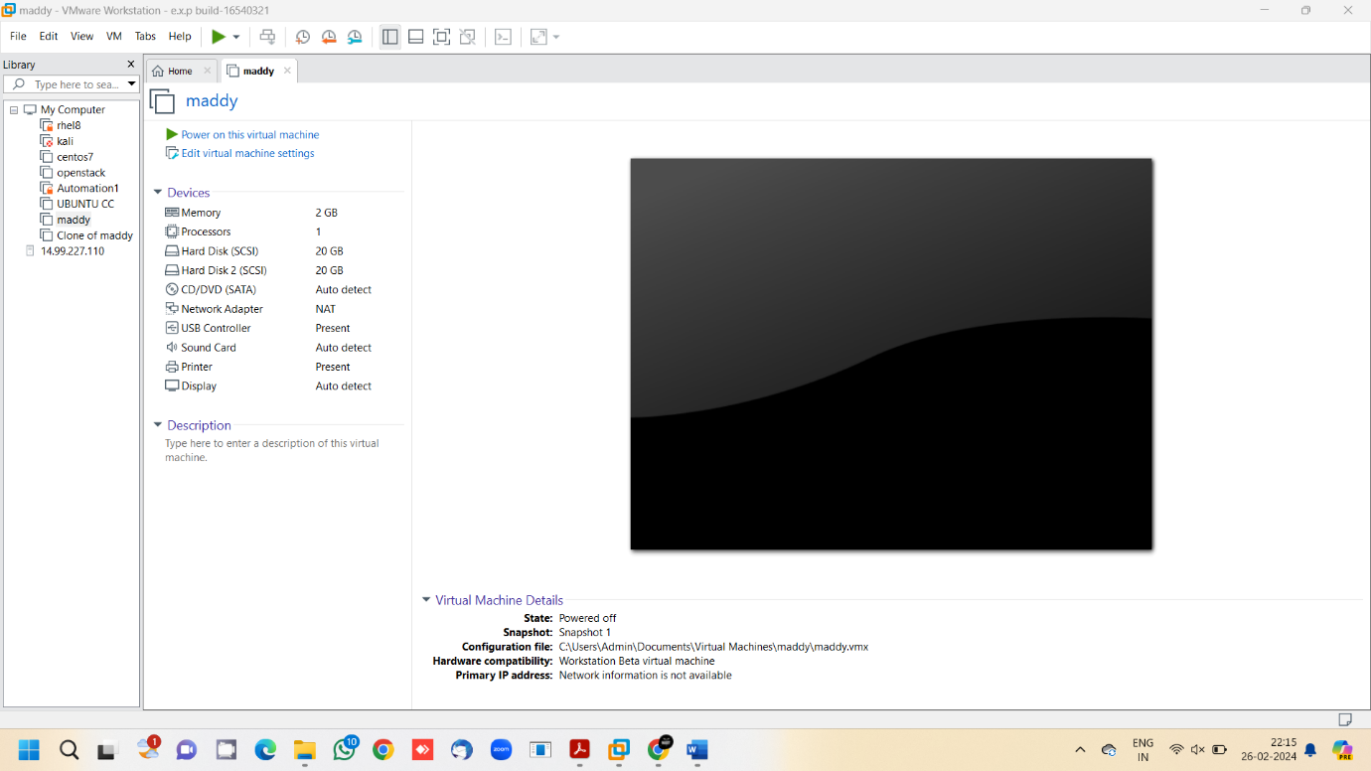

Step 2: - Click on VM, Manage, Change hardware compatibility

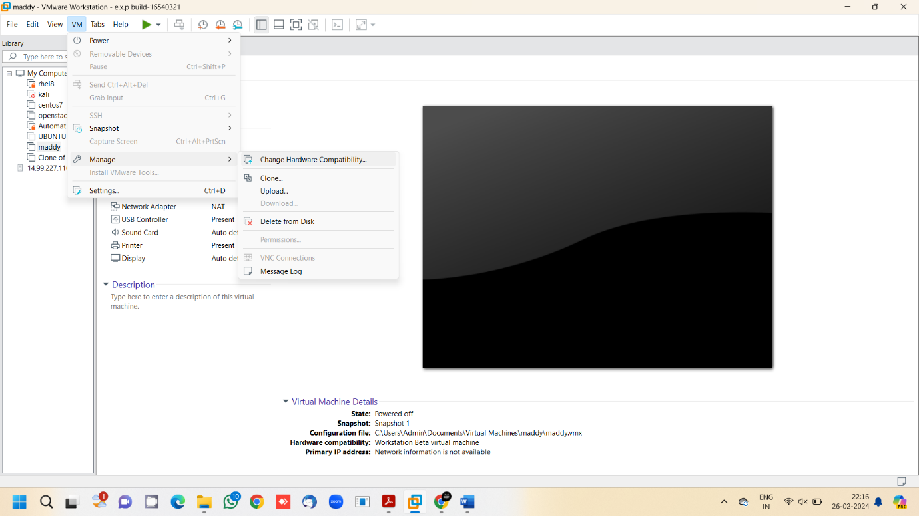

Step 3: - Click next on the appearing wizard and choose the required hardware in the next window and click next

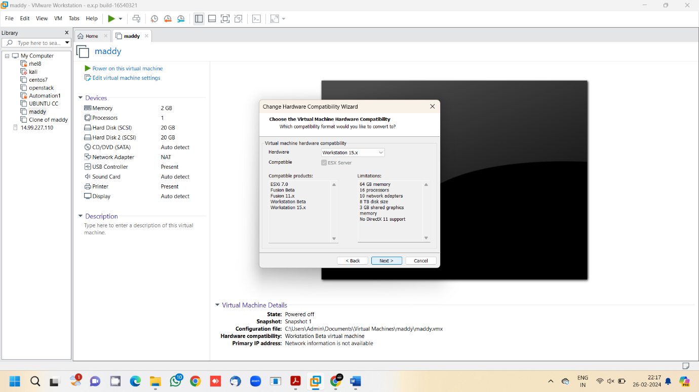

Step 4: - Create as a new clone and click next

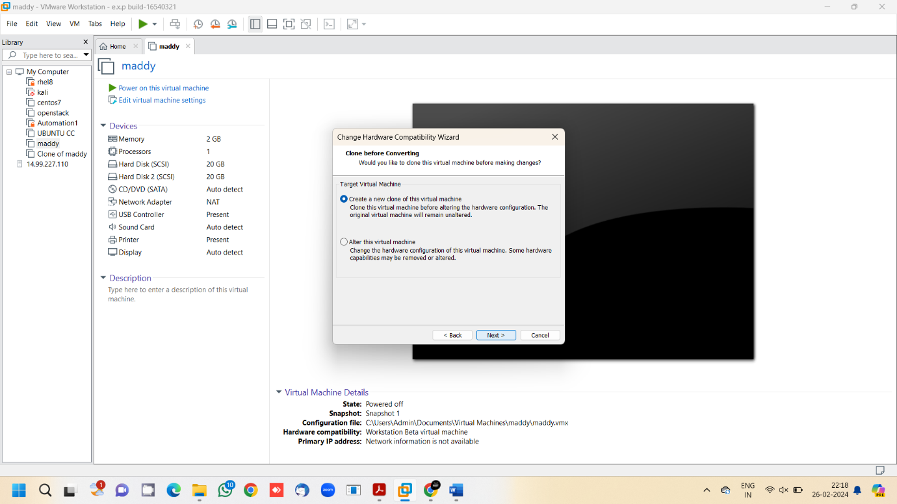

Step 5: - Enter name of the virtual machine and click next

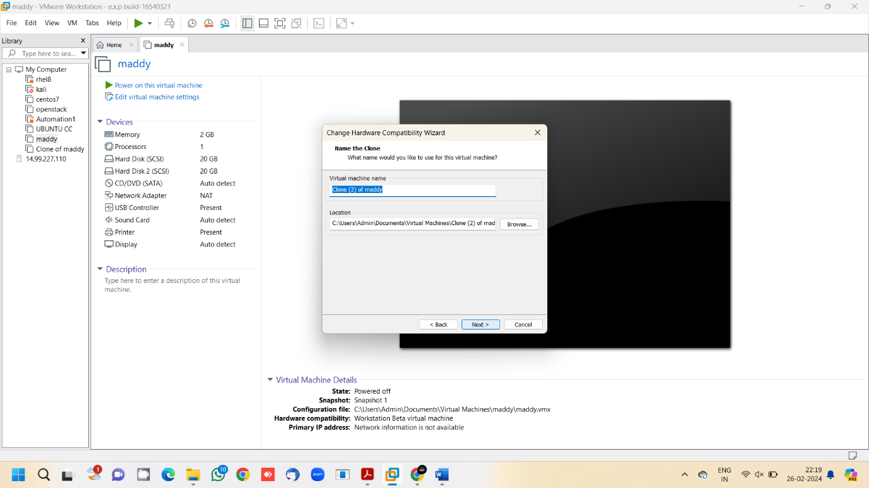

Step 6: - Review the changes and click on finish

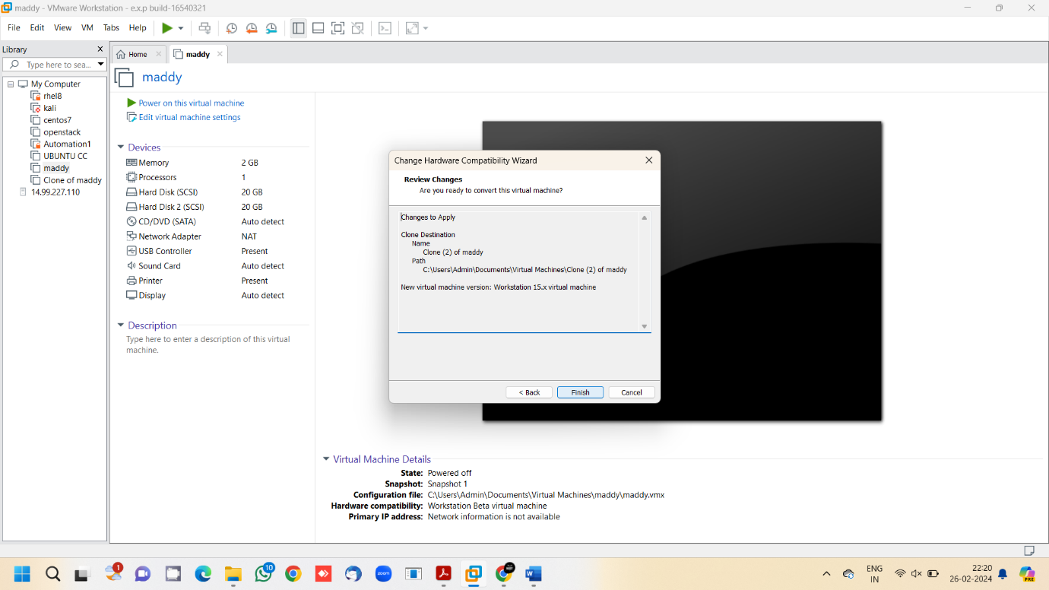

Step 7: - Cloning is successful

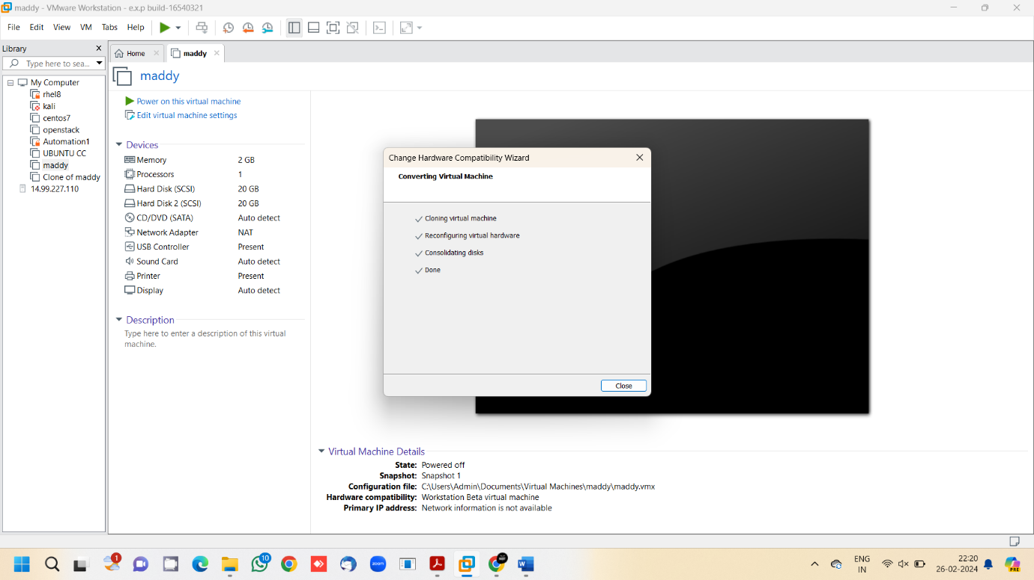

Step 8: - Clone of the virtual machine is now created successfully

